# C1- S4-PRACTICE

# Exercice 1

Q1 – Complete the **attributes type**s of Book and Read entities (5 points)

Q2 – Complete the **relation** between the Book and Reader entities (5 points)

|  |  |
| --- | --- |
| **Reader** | |
| ReaderID  Name  Class  Address | Numeric  String  String  String |

|  |  |
| --- | --- |
| **Book** | |
| BookID  Title  Publishment date  Language | Numeric  String  DateTime  String |

many

many

|  |  |
| --- | --- |
| **Reader** | |
| ReaderID  Name  Address  …………. | Numeric  String  String |

|  |  |
| --- | --- |
| **Book** | |
| BookID  Title  Language  ……………… | Numeric  String  String |

Q3 – We have created an **additional Associative table** to manage the previous relation between the Book and the Reader

* Complete the missing parts!

.

1

1

|  |  |
| --- | --- |
| **BookBorrow** | |
| BorrowID  Date borrow  Date return  ReaderID  BookID | PK  FK  FK |

many

many

# Exercise 2

Q1: complete the missing part of the model diagram below with PK as the primary or FK foreign key.

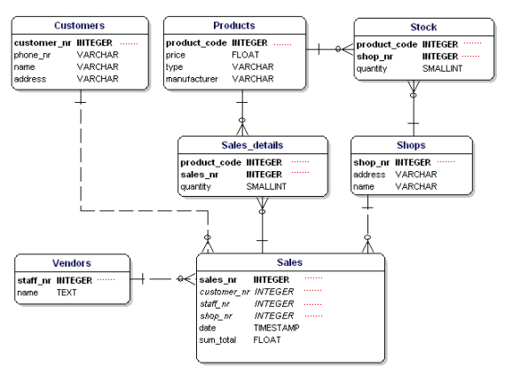

PK

PK

PK

FK

FK

PK

FK

PK

PK

FK

PK

PK

FK

FK

# Exercise 3

Q1: Complete the relation between each entity on the database relation model. Take for example the relation between **STUDENTS** and **PROJECTS.**

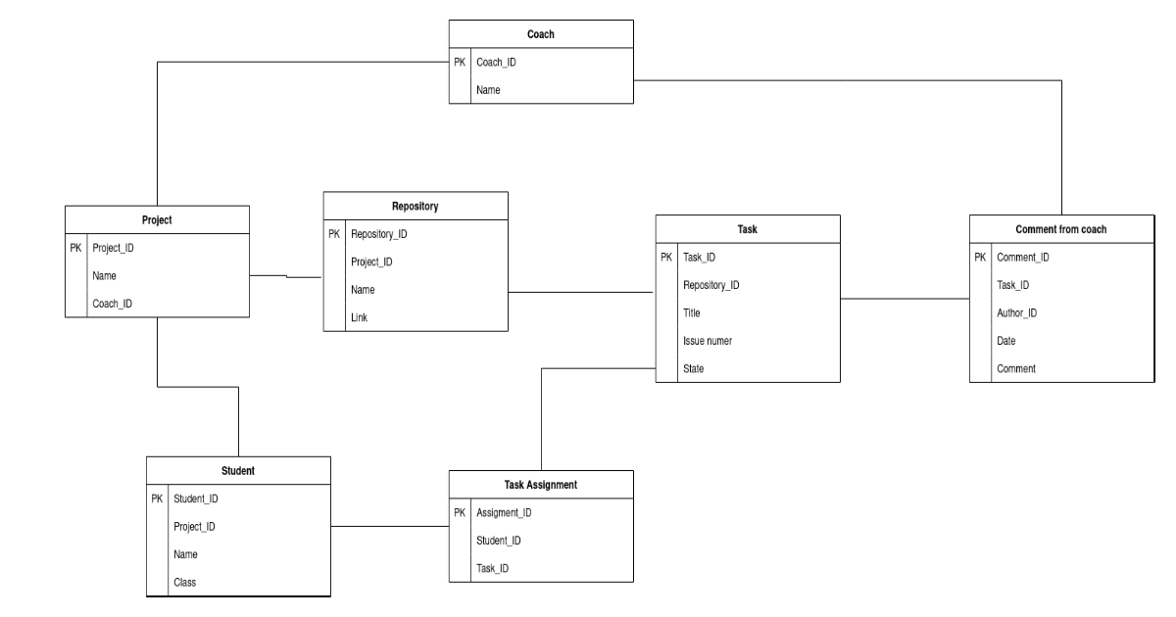

1

1

many

many

many

many

many

many

1

1

1

1

1

1

1

1

# Exercise 4

Google Classroom is the tool used to manage PNC classes, where the teacher can assign homework to the students of different classes.

**Q1**: Complete the attributes types in the following tables

|  |  |
| --- | --- |
| **User** | |
| user ID  email  password  name  role | **Numeric**  **String**  **Numeric**  **String**  **String** |

|  |  |
| --- | --- |
| **Classroom** | |
| classroom ID  name  section  subject | **Numeric**  **String**  **String**  **String** |

|  |  |
| --- | --- |
| **Assignment** | |
| assignment ID  title  description  deadline | **Numeric**  **String String**  **DateTime** |

|  |  |
| --- | --- |
| **Comment** | |
| comment ID  content  user ID  assignment ID | **Numeric**  **String Numeric**  **Numeric** |

Here are some observations that can help us design the Google Classroom database:

* A user can create many classrooms as a teacher
* A user can join many classrooms as a student
* A classroom can have many teachers
* A classroom can have many students
* A teacher can post many assignments in a classroom, and the same assignment can be posted in several classrooms
* An assignment post can have many comments from students or teachers

**Q2**   **CLASSROOM** and **ASSIGNMENT**

1. Type of relation: *one to one, one to many, many to many*?

* Many to many

1. Do you need to create an intersection table? Why?

* Yes, I do. because it’s many to many relationships.

1. Create the ERD representing to represent those 2 entities and their relation

1 1 many

|  |  |
| --- | --- |
| **Classroom** | |
| classroom ID  name  section  subject | **Numeric**  **String**  **String**  **String** |

|  |  |  |
| --- | --- | --- |
| **Classroom_Assignment** | | |
| ID | classroom ID | Assignment ID |

|  |  |
| --- | --- |
| **Assignment** | |
| assignment ID  1 many 1  title  description  deadline | **Numeric**  **String String**  **DateTime** |

**Q3:**   **COMMENT** and **ASSIGNEMENT**

1. Type of relation: *one to one, one to many, many to many*

* One to many

1. Do you need to create an intersection table or not? Why?

* No, I don’t. Because it’s one to many relationships.

1. Update the previous ERD to represent those 2 entities and their relation

|  |  |
| --- | --- |
| **Comment** | |
| comment ID  content  user ID  assignment ID | **Numeric**  **String Numeric**  **Numeric** |

|  |  |
| --- | --- |
| **Assignment** | |
| assignment ID  title  description  deadline | **Numeric**  **String String**  **DateTime** |

Many 1

**Q4:**   **COMMENT** and **USER**

1. Type of relation: *one to one, one to many, many to many?*

* One to many

1. Do you need to create an intersection table or not? Why?

* No, I don’t. Because it’s one to many relationships.

1. Update the previous ERD to represent those 2 entities and their relation

|  |  |
| --- | --- |
| **Comment** | |
| comment ID  content  user ID  assignment ID | **Numeric**  **String Numeric**  **Numeric** |

|  |  |
| --- | --- |
| **User** | |
| user ID  email  password  name  role | **Numeric**  **String**  **Numeric**  **String**  **String** |

Many 1